Toni IVERGARD, (Mr), Thailand, Management, "The social economy and Labour Economics"

9- Thai Economy and PEKEA framework of understanding
Natthawut SRIKATANYOO (Mr), Thailand, and Kitsada SIRIKUANG, (Mr),Thailand, " Responsibility of Tertiary Institutions to Thai Society"
Christina SAINT GERMAIN (Ms) Sweden, Thai Sustainable Economy”
18h – 20h Official Reception at the French Embassy

3rd November at DPU

8h 30 – 10h General Assembly
10h- 10h 30 Morning Coffee
10h 30 – 15h 45 Two plenary sessions from the workshops
15H 45 – 17h Roundtable as closing session
18h – 21h Cultural Show and Dinner hosted by DPU

__________________________________________________

«Our common future » was one of the four broad themes for elaboration emerging from our 1st conference in Santiago de 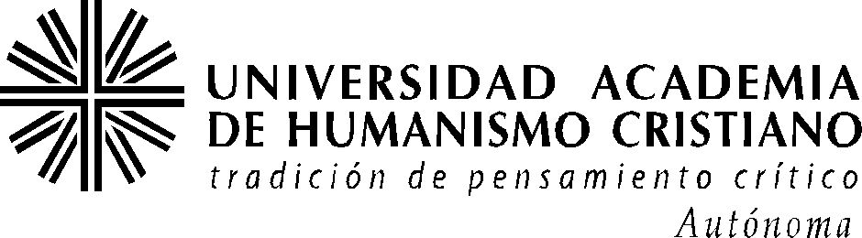. 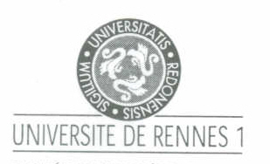 Chile (Sept 2002) organised with UAHC . Then at University of Rennes 1 in December 2003, we focused on the first broad theme: « the societal value ». We explored what was required for a responsible humanity, i.e. the conditions for living in a fraternal manner according to the triptych "Liberty - Equality - Fraternity" that is found in the preamble of the Indian constitution and of several African Countries as well as the French Republic.

In Bangkok we will elaborate some core issues concerning «Our common future » : objectives and priorities ; the responsibility of different actors ; and the nature and operation of the global systems of governance necessary to promote this future. Thus our endeavours must promote the delivery and discussion of observations, experiences and/ or analyses drawing on at least two disciplines to help refine some key sets of issues (our four blocks of knowledge to build ) concerning «Our common future ».

PEKEA a global think tank network
With more than 700 researchers, and thousands of people involved in partner associations and local authorities
http://www.pekea.org

__________________________________

What feasible common future ?

_____________________________________

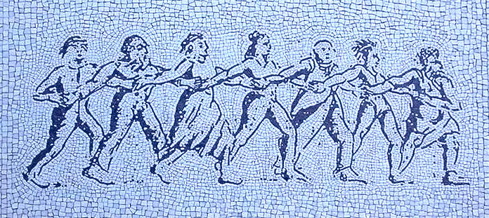

Academics and the civil society
are invited to devise an economy
with a human face,
for a common future world,
where we will live happy altogether.

A Conference co-organised by PEKEA
and Dhurakijpundit University, DPU
with the support of
Conseil Régional de Bretagne

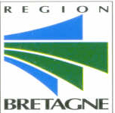

P E K E A
Political and Ethical Knowledge on Economic Activities

Quel futur commun possible?
What feasible common future?
¿ Que futuro común posible ?



Conference and General Assembly
Bangkok, 1 - 3 Nov 2004

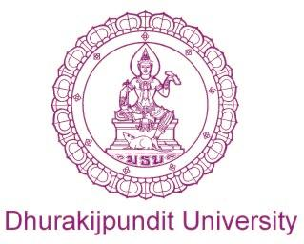

Co-hosted by ESCAP and DPU
ESCAP : The Economic and Social Commission
For Asia and the Pacific (UN)

